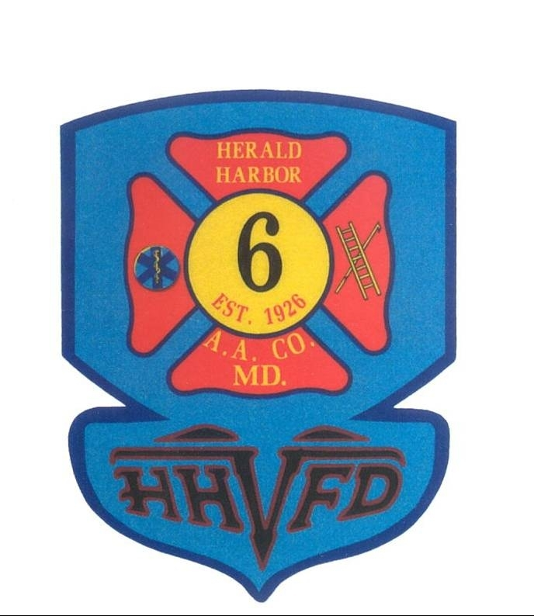

Herald Harbor Volunteer
Fire Department

401 Hall Road
Crownsville, MD 21032

MEMBERSHIP APPLICATION

Personal Info:

Name___________________________ Nickname/Preferred Name_______________ Sex M F

Occupation: _____________________ Social Security #_______________DOB:_____________

Home# __________________________ Work#_____________________Cell:___________________

Home Address: _____________________________________________________________________
Street City State Zip

e-mail:_____________________________ Drivers License #____________________ St: __ Class: __

Please list any Fire, EMS or Rescue related courses you have taken. (Example: FF I, EMT, etc.)

*_______________________________________________________________________________

*_______________________________________________________________________________

*_______________________________________________________________________________

References:

Please list at least tow professional and one personal reference, Include name, contact info, relationship

*_________________________________________________________________________________

*_________________________________________________________________________________

*_________________________________________________________________________________

Availability:
Our members are the core and essence of the Herald Harbor Volunteer Fire Department. Participation is key in maximizing your fulfillment of this volunteering endeavor. If possible, list the days and times you would consider participating in the functions and activities at the Herald Harbor Volunteer Fire Department.

Mon ___ Tues ___ Wed ___ Thurs ___ Fri ___ Sat ___ Sun ___

General:
Have you ever been convicted of a Misdemeanor or Felony? ______ Yes _______ No
( A “Yes” answer does not automatically disqualify you – the date and nature of the offence will be considered.:

I _____________________________ hereby authorize Anne Arundel County and/or the Herald Harbor Volunteer Fire Department to investigate any and all statements made herein. I understand that any false statements or an omission of information requested is cause for rejection of my application.

I agree to abide by the Constitution and By-Laws of Herald Harbor Volunteer Fire Department and all rules and regulations set for by the Board of Directors and Company.

My signature on this application indicates that I understand that my membership is dependent upon my successful completion of a physical examination including CDS testing to be conducted by the Medical Services Office of the Anne Arundel County Fire Department.

Membership dues of $13.00 for the first year MUST accompany this application for presentation to the Board of Directors and General Membership. Membership dues of $10.00 will be collected annually.

_______________________________________ ______________________

Signature Date

If under the age of 18, a signature of a parent or legal guardian MUST accompany this form.

________________________________________ ______________________

Parent/Guardian Date

_________________________________________ ______________________

Witness Date
Administrative Only

Interviewed by:__________________ Date of Interview:_________________
Date Membership Committee Reviewed:__________________
Date of General Membership Review:______________ Date of Membership:_______________
Probationary Ending Date:_________________________ Date of Final Membership:___________

Notes:_______________________________________________________________________
__________________________________________________________________________________

